**عبدالرحمن احمد يسري النعناعي 19015889**

**محمود ابراهيم جاد ابوالوفا 19016532**

**صلاح الدين احمد محمد السيد 19015854**

**احمد هشام عبدالرزاق محمود 19015378**

**AI LAB 2**

Comparison between Minimax and alpha-beta pruning



Alphabeta traverses different number of nodes each time

This is an initial estimate

Minimax traverses all possible states for a given depth

These are initial plays

**Sample runs :-**

**Minimax without pruning:**

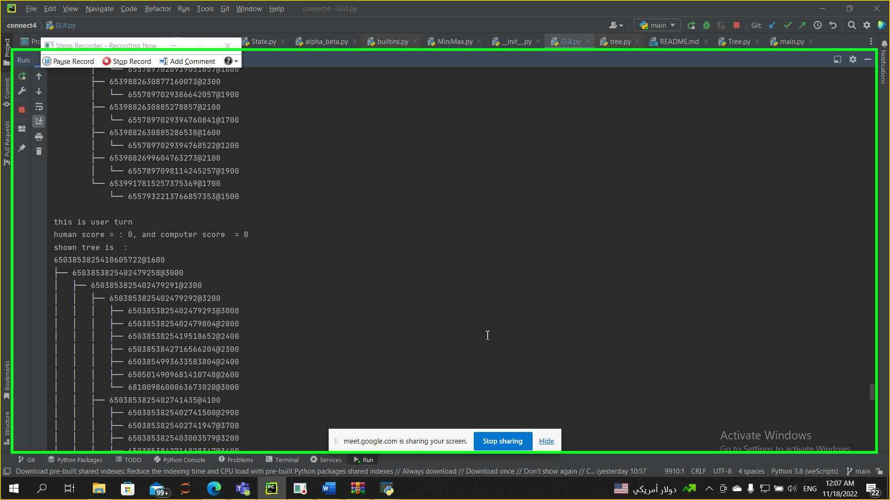

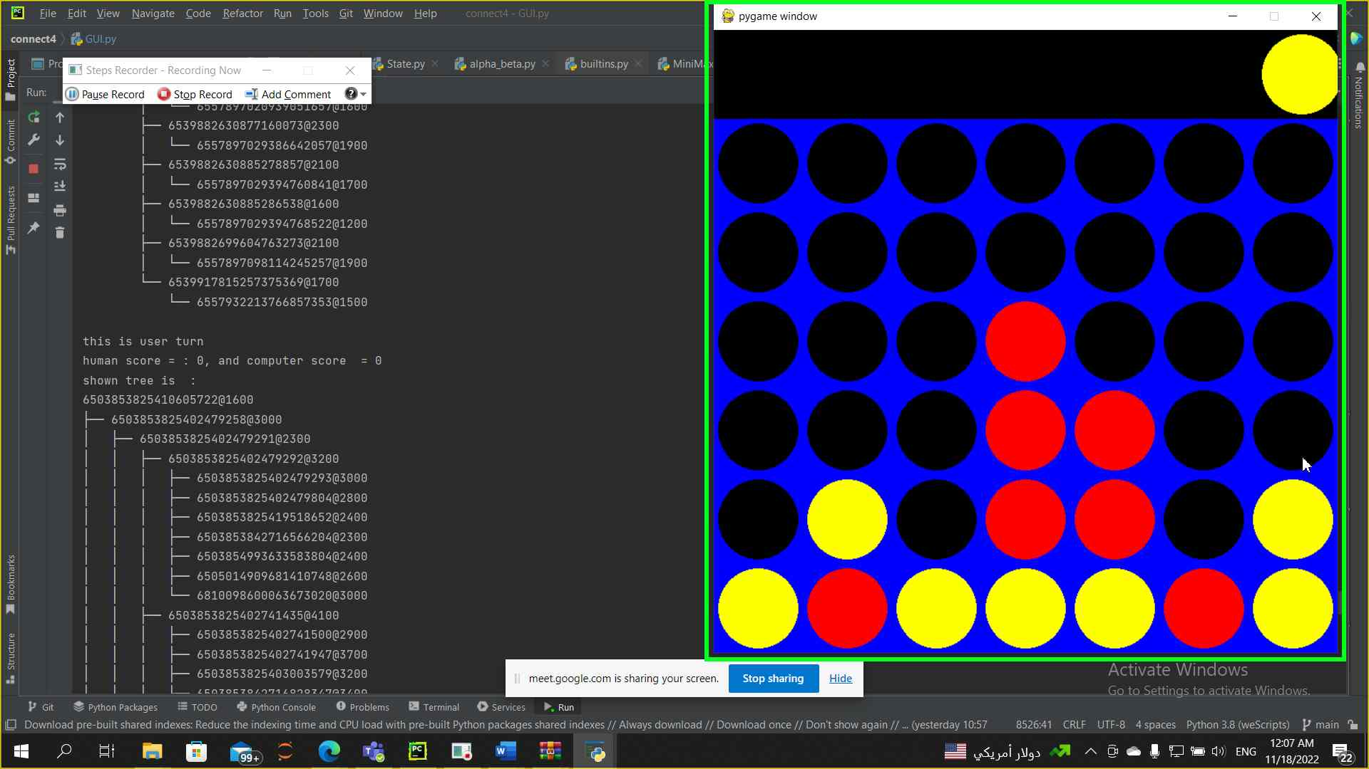

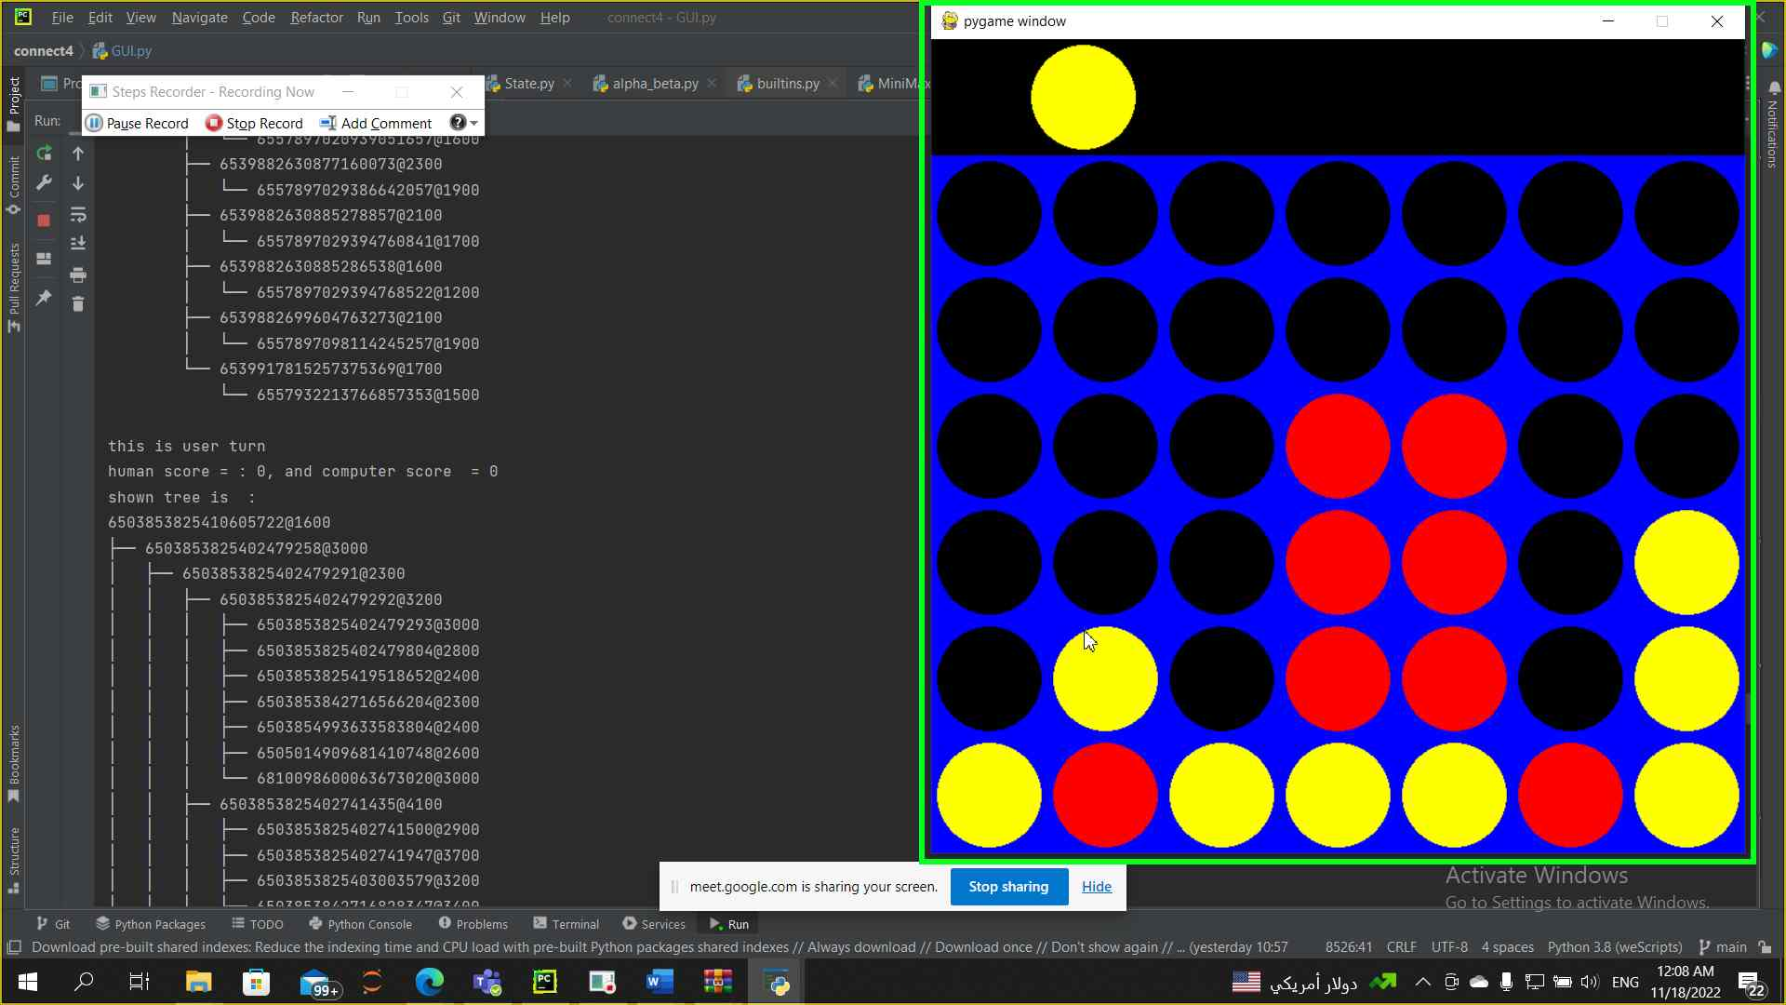



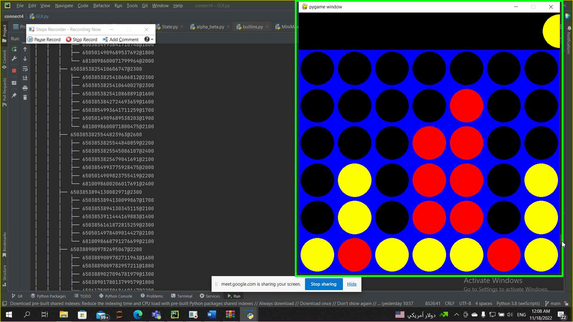

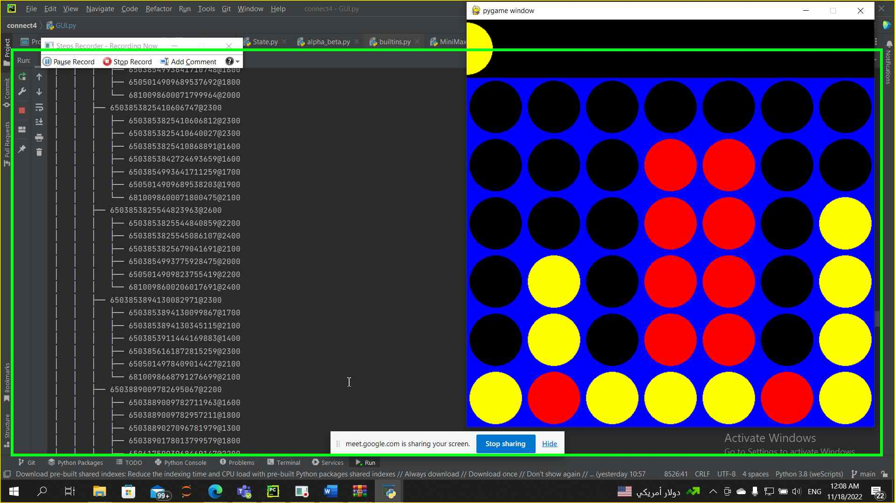

**Minimax with pruning :-**

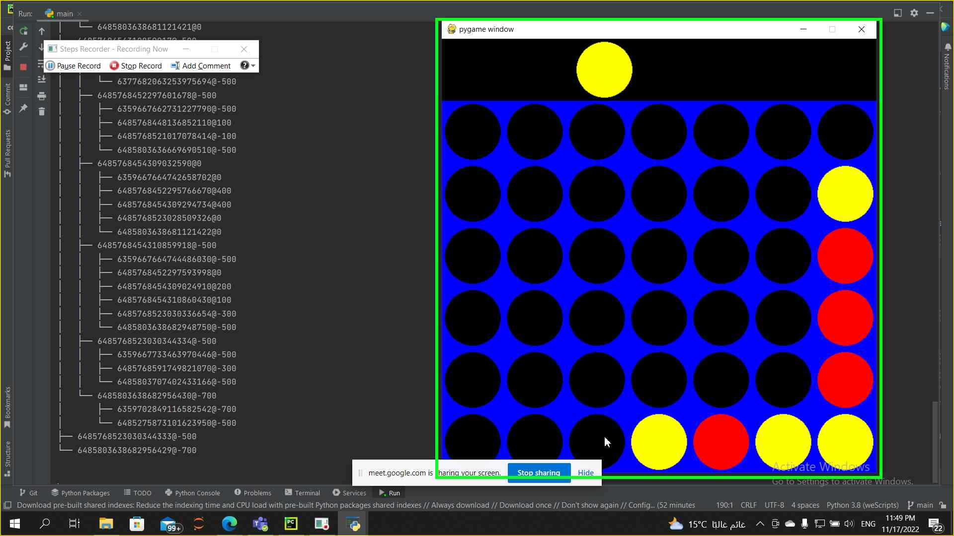

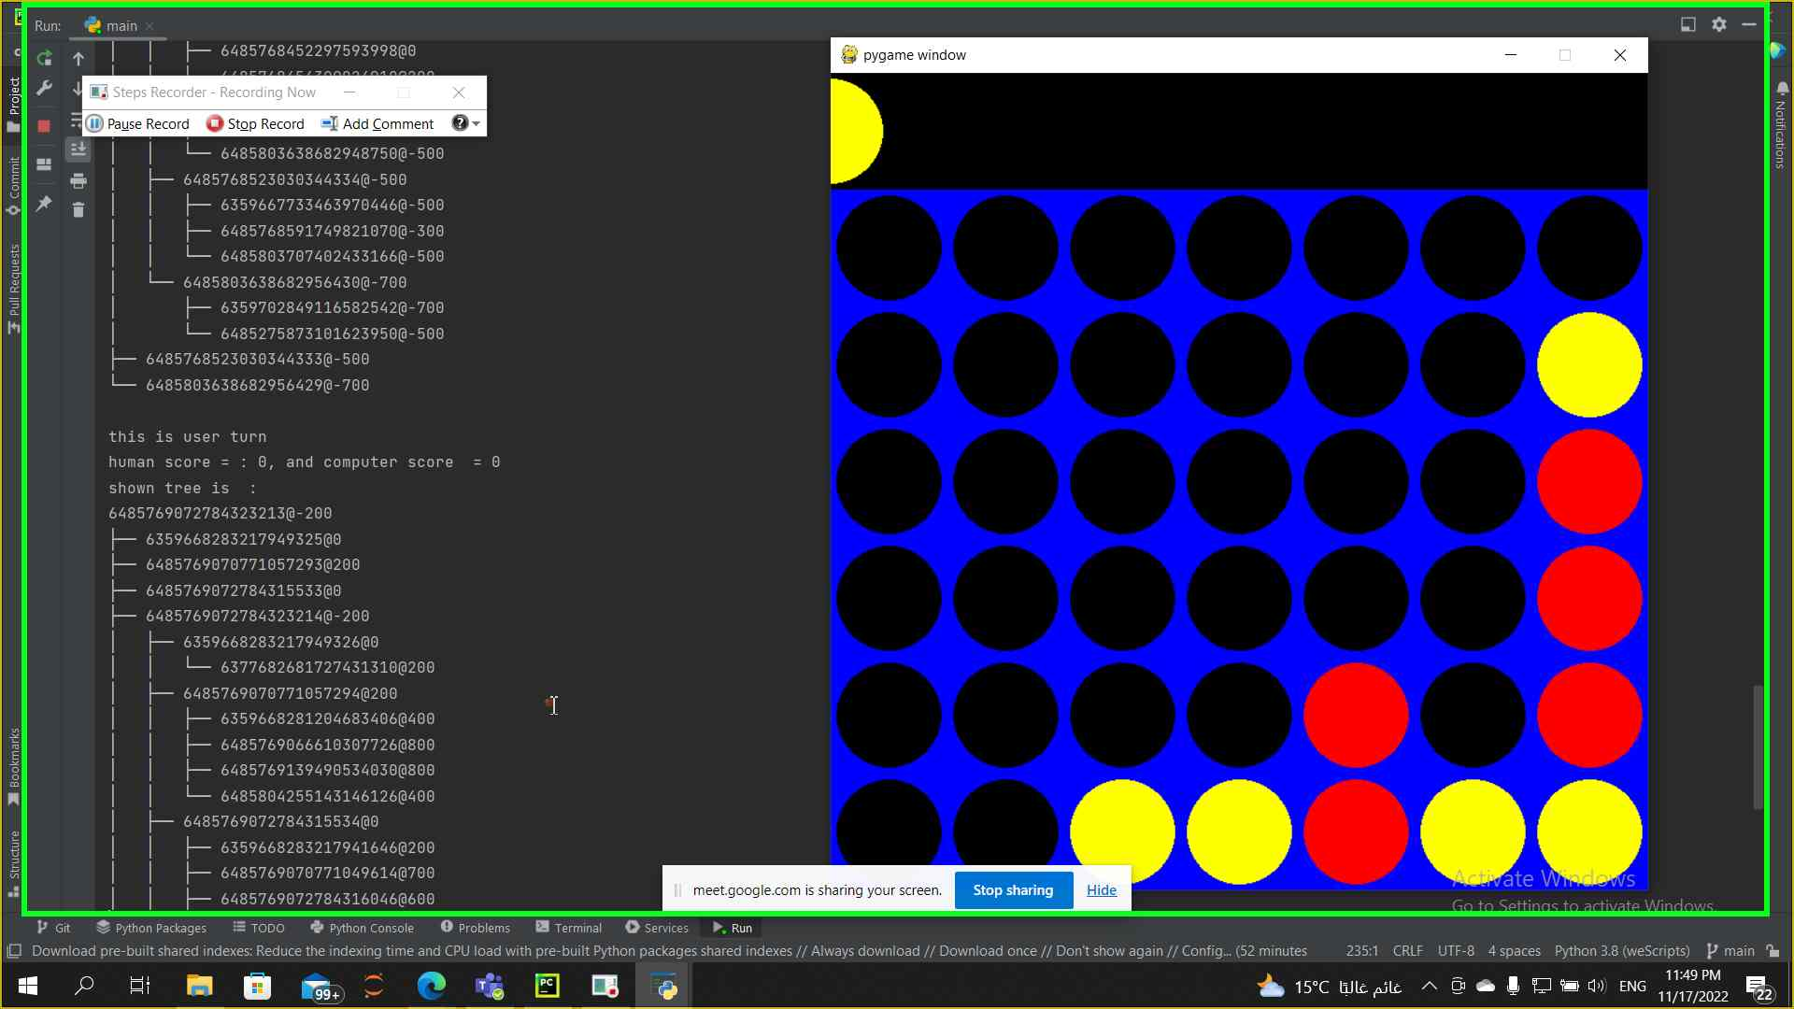

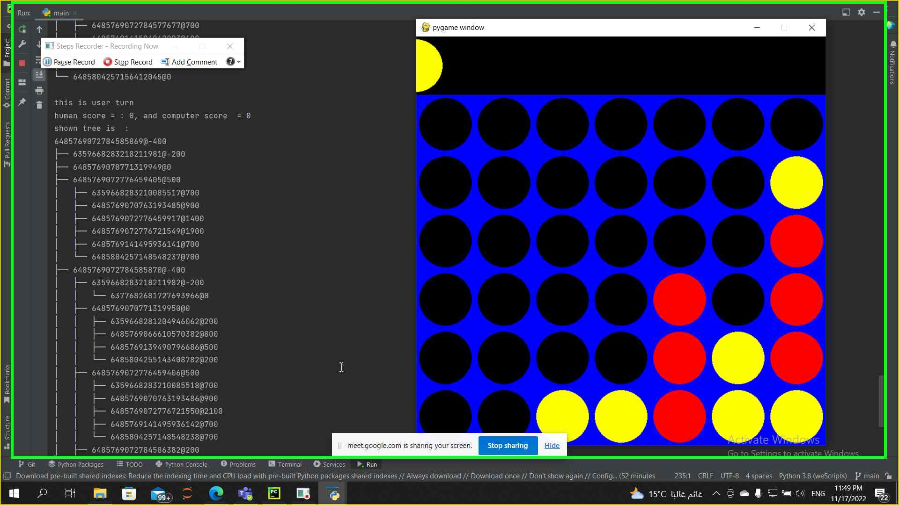

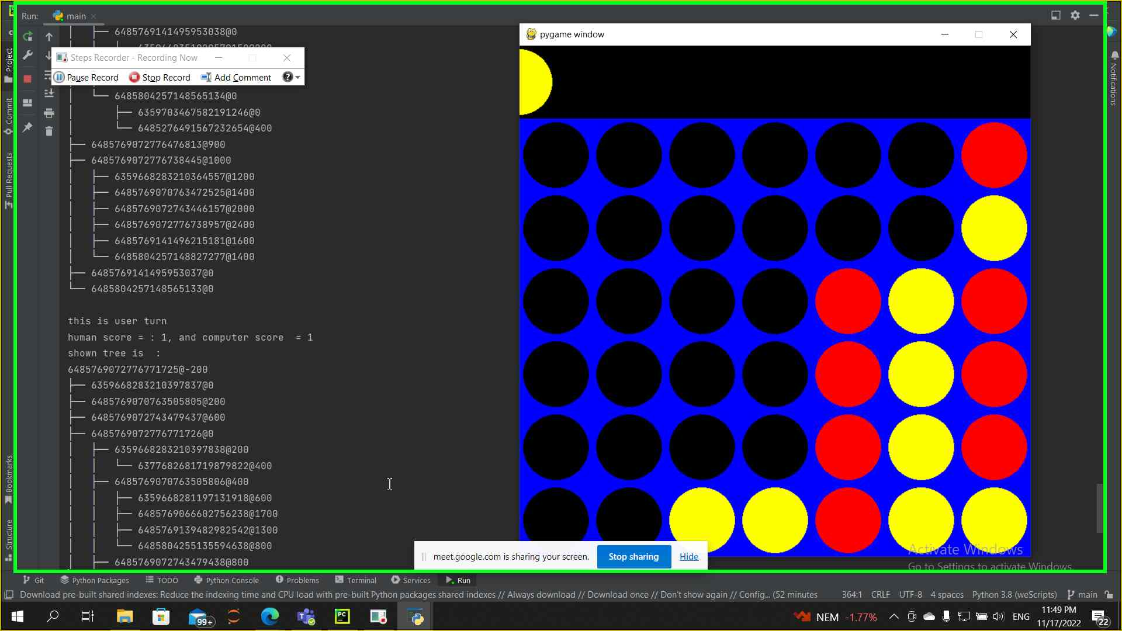

**Data structure used :-**

* Dictionary
* List
* 2d array

**Algorithms applied :-**

* Minimax without pruning
* Minimax with pruning
* A heuristic function was used in both cases to estimate the case of the state